**My, Art 385, Simple State Machine, 03/24/2020**

**Assignment**

Create a state machine that changes colors every 4th click.

**Diagrams**

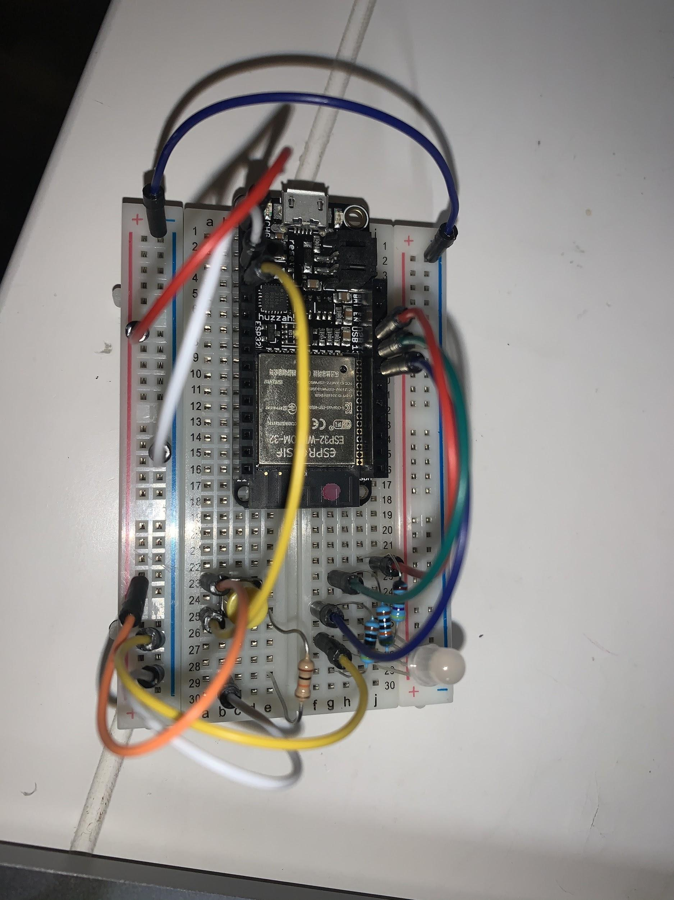

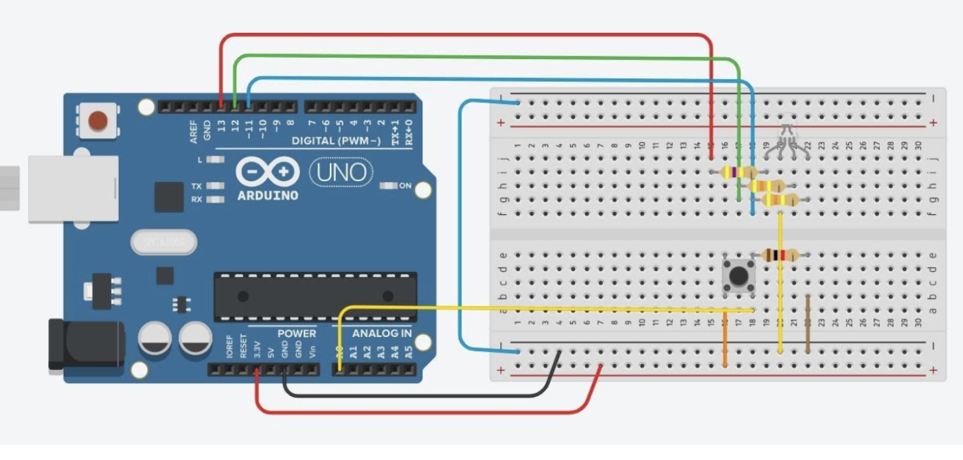

**Reflections**

I am slowly understanding the whole circuit situation and why certain wires go where they go. I am still having a hard time with consistency because sometimes when I upload the code, it works, but then when I try the next day or something, it seems to take a while for the LED to light up. Besides, small hiccups, I am understanding the coding aspects more than before.